Experiment 3
Predictive Parsing

Grammar:

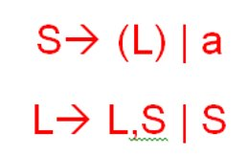

After removing ambiguity
(no ambiguity)

After removing left recursion
S->(L)|a
L->SA
A->,SA|epsilon

Code:

#include<stdio.h>
#include<stdlib.h>
#include<string.h>

int i=0,top=0;
char stack[20],ip[20];
void push(char c)
{
if(top>=20)
printf("stack overflow");
else
stack[top++]=c;
}

void pop(){
if(top<0)
printf("stack underflow");
else
top--;}

void error()
{
printf("\nsyntax error\n");
exit(0);}

int main()
{
int n;

printf("Enter the string to be parsed:\n");

scanf("%s",ip);
n=strlen(ip);
ip[n]='$';
ip[n+1]='\0';
push('$');
push('S');
while(ip[i]!='\0')
{
if(ip[i]=='$' && stack[top-1]=='$')
{
printf("\nsuccessful parsing\n");
return 0;}
else if(ip[i]==stack[top-1])
{
printf("\nmatch of %c\n",ip[i]);
i++;
pop();
}

else
{
if(stack[top-1]=='S' && ip[i]=='a')
{
printf("\nS->a");
pop();
push('a');}

else if(stack[top-1]=='S' && ip[i]=='(')
{
printf("\nS->(L)");
pop();
push(')');
push('L');
push('(');
}
else if(stack[top-1]=='L' && (ip[i]=='a' || ip[i]=='('))
{
printf("\nL->SA");
pop();
push('A');
push('S');

}

else if(stack[top-1]=='A'&& ip[i]==',')
{
printf("\nA->,SA");
pop();
push('A');
push('S');
push(',');
}
else if(stack[top-1]=='A' && ip[i]==')')
{
printf("\nA->epsilon");
pop();}

else
error();
}
}
return 0;
}

Output:
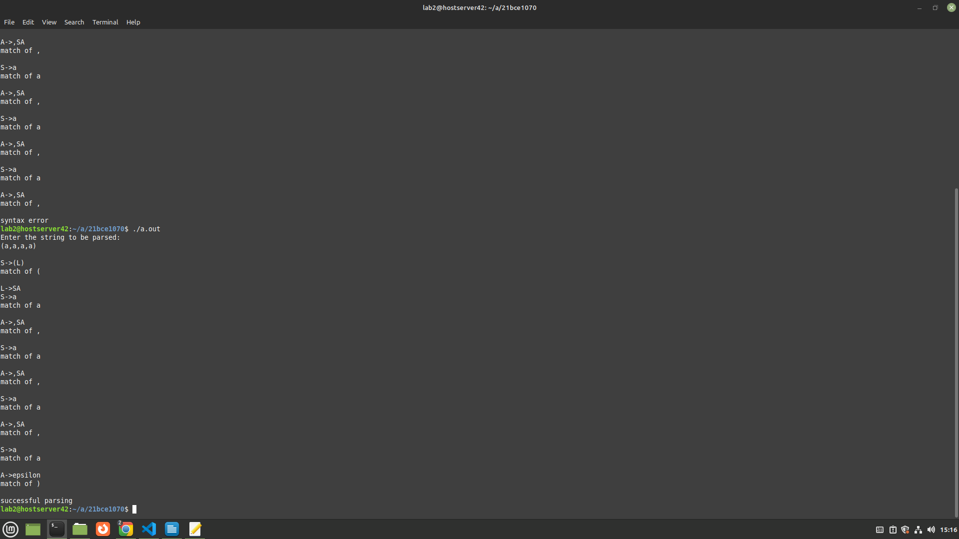

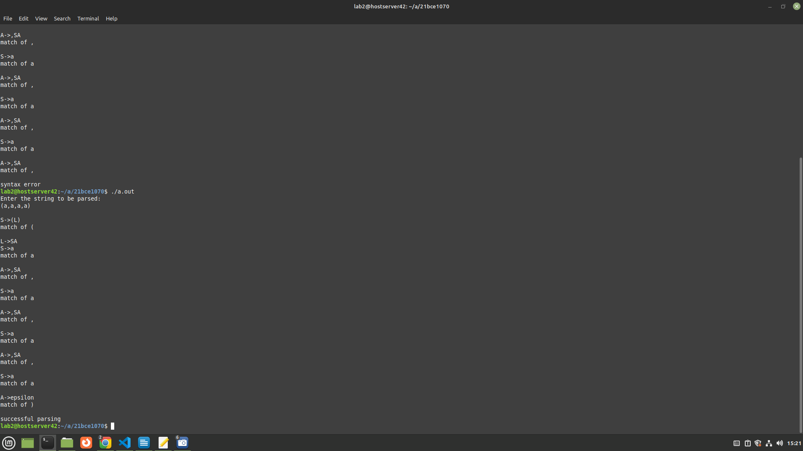

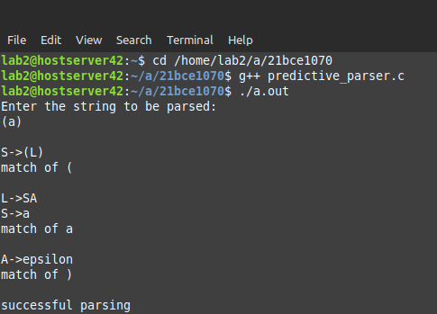

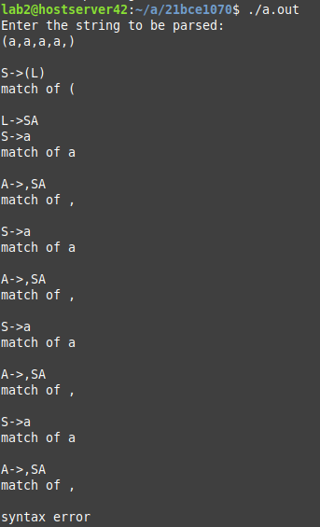

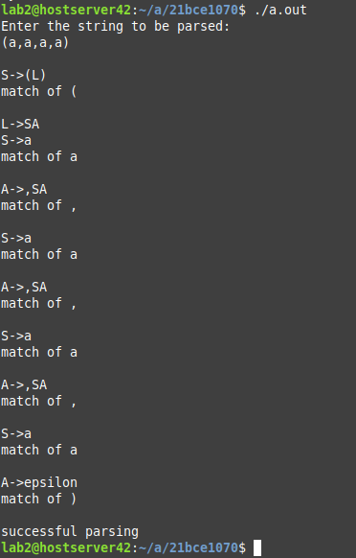

Other Grammars:

S->SS|a|b

Ambiguity removal

S->ST|T
T->a|b

Remove Left recursion

S-> TX|
X-> TX|epsilon
T->a|b

#include<stdio.h>
#include<stdlib.h>
#include<string.h>

int i = 0;
char input[20];

void match(char expected) {
if (input[i] == expected) {
i++;
} else {
printf("\nSyntax error: Expected '%c' but found '%c'\n", expected, input[i]);
exit(0);
}
}

void S();
void X();
void T();

void S() {
if (input[i] == 'a' || input[i] == 'b') {
T();
X();
} else {
printf("\nSyntax error: Unexpected symbol '%c'\n", input[i]);
exit(0);
}
}

void X() {
if (input[i] == 'a' || input[i] == 'b') {
T();
X();
} else if (input[i] == '\0' || input[i] == '$') {
// epsilon production
} else {
printf("\nSyntax error: Unexpected symbol '%c'\n", input[i]);
exit(0);
}
}

void T() {
if (input[i] == 'a') {
match('a');
} else if (input[i] == 'b') {
match('b');
} else {
printf("\nSyntax error: Unexpected symbol '%c'\n", input[i]);
exit(0);
}
}

int main() {
printf("Enter the string to be parsed:\n");
scanf("%s", input);

S(); // Start the parsing process with the start symbol S

if (input[i] == '\0') {
printf("\nSuccessful parsing\n");
} else {
printf("\nSyntax error: Unexpected symbol '%c'\n", input[i]);
}

return 0;
}

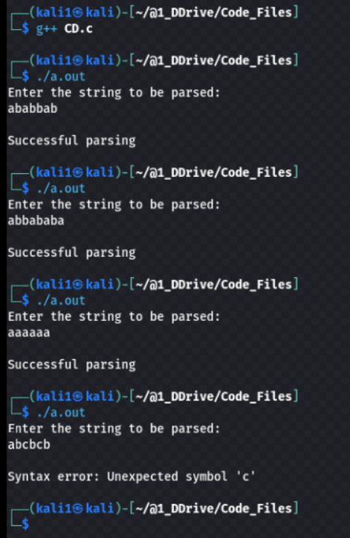

S->aA|bA
A->aA|bA|epsilon
(no ambiguity, left recursion, left factoring)

#include <stdio.h>
#include <stdlib.h>
#include <string.h>

int i = 0, top = 0;
char stack[20], ip[20];

void push(char c) {
if (top >= 20)
printf("stack overflow");
else
stack[top++] = c;
}

void pop() {
if (top < 0)
printf("stack underflow");
else
top--;
}

void error() {
printf("\nsyntax error\n");
exit(0);
}

int main() {
int n;
printf("Enter the string to be parsed:\n");
scanf("%s", ip);
n = strlen(ip);
ip[n] = '$';
ip[n + 1] = '\0';
push('$');
push('S');

while (ip[i] != '\0') {
if (ip[i] == '$' && stack[top - 1] == '$') {
printf("\nsuccessful parsing\n");
return 0;
} else if (ip[i] == stack[top - 1]) {
printf("\nmatch of %c\n", ip[i]);
i++;
pop();
} else {
if (stack[top - 1] == 'S') {
if (ip[i] == 'a') {
printf("\nS -> aA");
pop();
push('A');
push('a');
} else if (ip[i] == 'b') {
printf("\nS -> bA");
pop();
push('A');
push('b');
} else {
error();
}
} else if (stack[top - 1] == 'A') {
if (ip[i] == 'a') {
printf("\nA -> aA");
pop();
push('A');
push('a');
} else if (ip[i] == 'b') {
printf("\nA -> bA");
pop();
push('A');
push('b');
} else if (ip[i] == '$' && stack[top - 1] == 'A') {
printf("\nA -> epsilon");
pop();
} else {
error();
}
} else {
error();
}
}
}
return 0;
}

